All – regarding Module 4 assignment, all you need to do is to **Import** (Eclipse Help menu->Welcome->Import existing projects) the given [gameauth.zip](https://learn.snhu.edu/content/enforced/1232220-CS-230-T3264-OL-TRAD-UG.23EW3/Course%20Documents/gameauth.zip?_&d2lSessionVal=i1i68aB5a8BxMreaPRUHUPbRu&ou=1232220) skeleton/template/starter project in **Eclipse**. Then update the FIXME (Eclipse Window menu->Show View->Tasks) code items according to the steps outlined in the code in the following articles:

**Dropwizard – BasicAuth Security Example:**[**https://howtodoinjava.com/dropwizard/dropwizard-basic-auth-security-example/**](https://howtodoinjava.com/dropwizard/dropwizard-basic-auth-security-example/)

**Consume Dropwizard REST APIs with Jersey/HTTP Client:**[**https://howtodoinjava.com/dropwizard/client-configuration-and-examples/**](https://howtodoinjava.com/dropwizard/client-configuration-and-examples/)

Then, in Eclipse, Select the “gameauth” project in Package Explorer and then click the **Run** button from the **Run** menu.

After that navigate to the **Run Configurations** dialog by right clicking the “gameauth” project in Package Explorer->then clicking **Run As**-> then clicking **Run Configurations**.

Remember to add the values “server config.yml” as Program Arguments on the **Arguments** tab of **Run Configuration**.

Click the **Run** button in the **Run Configurations** dialog.

After that navigate to a **Google Chrome browser** and type the below in the address bar and hit **Enter**.

<http://localhost:8080/gameusers>

You would see below Sign in page:

**Use username:** “admin” and password: password to Sign in.

You should see below:

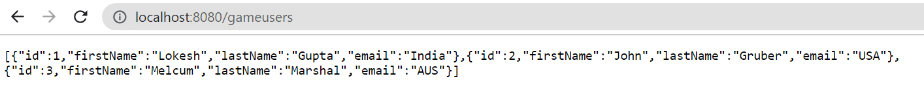

You may not need to work on Dropwizard Hello World tutorial to complete your assignment. That tutorial is just a guide to learn the steps and concepts that might be helpful in completing the assignment.

Hope this helps!

Thanks,

Suhash